Beltone 2nd AI Hackathon

Powered by: Robin

Problem Statement Overview:
Efficient multi-warehouse vehicle routing problems (MWVRP) are a critical challenge in modern logistics. Traditional algorithms struggle to handle the complexity, having to account for:
- Limited inventory distributed across multiple warehouses
- Directional road network constraints
- Vehicular capacity limits (weight & volume)
- Multi-warehouse pickup coordination
- Real-time inventory tracking during routing
Participants must design an intelligent optimization solver that dynamically plans delivery routes which:
- Respect road network connectivity
- Allocate and track inventory across warehouses
- Ensure vehicle capacity feasibility
- Sequence pickups across multiple depots correctly
- Optimize cost, efficiency, and fulfillment rates
The solution will be evaluated on order fulfillment, operational cost minimization, vehicle utilization, and real-world feasibility under constrained and imperfect logistics conditions.

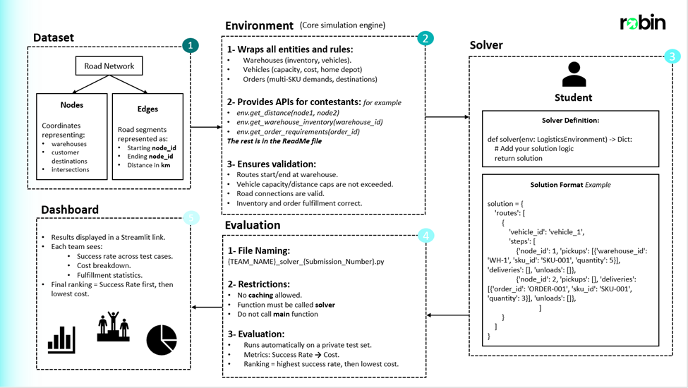
and API Reference file

Dataset:
The dataset used is a collection of entries that represent locations in all of Cairo. The dataset models roads and locations in Cairo as a graph network comprised of nodes and edges. This data is represented as follows:
- Nodes: These represent a landmark in Cairo identified as co-ordinates.
- Edges: These represent directional links between 2 Nodes (not necessarily bidirectional), identified using the 2 nodes and the length between them.
This image shows a small portion of the dataset highlighting the area from Masr el-gedida and Madinat Nasr to the beginning of El-Rehab City.
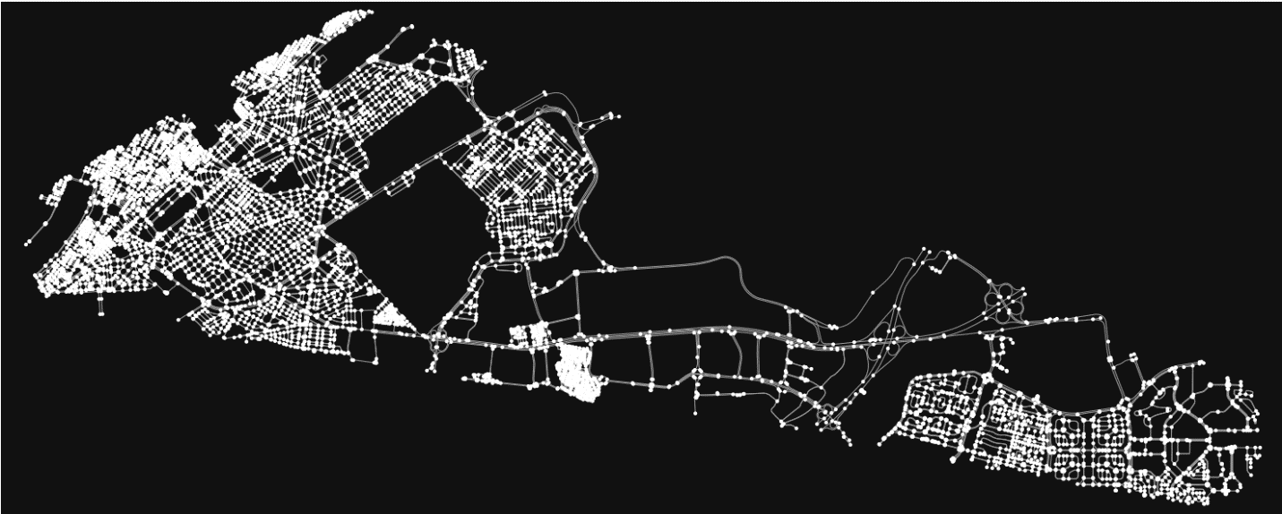

Environment:
The Robin Logistics Environment simulates a large-scale real-world logistics network for solving multi-warehouse vehicle routing problems (MWVRP) under strict operational constraints.
- Road Network: 332k nodes, directional/bi-directional roads, Dijkstra-based pathfinding.
- Warehouses: Multiple depots with limited inventories and defined vehicle fleets.
- Vehicles: Light vans to heavy trucks, capacity (weight & volume) limits, fixed + variable costs, max distance constraints.
- Orders & Inventory: Multi-SKU customer orders, distributed demand, real-time inventory tracking, scarcity-driven allocation.
- Constraints:
  - Routes start/end at home warehouses
  - Capacity checks at every step
  - Valid road connections only
  - Full order fulfillment (partials take points but not fully)
  - One route per vehicle
  - Running-Time of solvers submitted should not exceed 30 minutes (more than this won’t be evaluated)
  - Environment manipulations or altercations is NOT ALLOWED (don’t play in environment, which is robin-logistics-env)
  - Building a string solution is not allowed, solver is being evaluated against environment and scenarios.
  - Has to be a Python (.py) file.
- Allowed:
  - Multi-pickup from several warehouses
  - Multi-vehicle per order
  - Unload to any warehouse
  - Directed roads
  - Vehicles start/end at home warehouse
Challenge Characteristics (Variable to change according to scenario): 50 orders, 12 vehicles, 3 SKUs, 2 Warehouses and constrained resources over a massive road network. Solutions must optimize cost, capacity use, and fulfillment rates while passing strict validation on connectivity, inventory, and business logic compliance.
Please use “pip install robin-logistics-env" to install the environment.

Evaluation:

Process
- Solvers are tested on Private Scenarios (hidden) and 5 Public Scenarios (for local testing).
- Each private scenario evaluates both cost efficiency and fulfillment rate.
- Presentation will be held for top teams after deadline, to present solutions against the panel, affecting final ranking

Scoring Equation
For every scenario:
Scenario Score=Your Scenario Cost + Benchmark Solver Cost × (100 − Your Fulfillment %)
- Lower = Better
- Missing fulfillment is heavily penalized.
- Once fulfillment is high, cost efficiency becomes the differentiator.

Dynamic Ranking & Points
- After computing scenario scores for all solvers, they are ranked dynamically (lowest → highest score).
- Points are awarded based on rank:
  - Rank 1 = 20 points
  - Rank 2 = 19 points
  - Rank 3 = 18 points
  - … and so on.
- Final score = sum of points across all private scenarios.
This ensures:
- Rankings shift dynamically as new solvers are submitted.
- Strong, consistent performance across scenarios matters more than excelling in just one.
- Even a single weak scenario can change the leaderboard significantly.

Leaderboard
- Updated live throughout the hackathon.
- Displays each team’s total points across all scenarios.
- The leaderboard is dynamic — every submission can reshuffle rankings.

Submission:
Link for the submission portal: AI Hackathon Submission
All participating teams have to follow a strict pipeline for submissions. The submission process will be done as:
- After testing the model locally, the model should be saved as a .py file using the following naming convention {TEAM_NAME}_solver_{Submission_Number} e.g.(Robin_solver_1), The submission number starts from 1 and is incremented by 1 for every submission. (It is the team’s responsibility to ensure the correct naming for each submission, any inconsistencies may result in an unevaluated submission)
- The Model is then evaluated automatically using a private testing set.
- The results will be posted on a live leaderboard hosted on Streamlit. Results Dashboard

Rules and Regulations:
- The submitted file must have a main function defined as follows:
def solver(env):
- The submitted file MUST NOT use any caching techniques.
- Do not import or initialize the environment inside the solver function only in main
- Comment out the main function when submitting the solver file

Starter Skeleton — baseline solver to get participants started
Below is a compact, ready-to-run baseline skeleton you can include in your repository and adapt. It is intentionally simple and meant as a launchpad. Use it to get fast local runs and then iterate.
Solver skeleton is included as a python file named solver.py
----------------------------------------------------------------------------------------------------------------------------------

Local Scenario Dashboard – Statistics based on your solver (optional):
run_dashboard.py is a file that when runs a dashboard that helps you to visualize your solver – this is an optional tool
Dashboard is included as a python file named run_dashboard.py
----------------------------------------------------------------------------------------------------------------------------------
Functions Documentation Excel file:
Included is an excel file named functions_exmaples_documentation, which contains a documented rows of functions , with examples of it’s input and output used for the Hackathon Problem.
Excel file name is functions_examples_documentation

Submission Portal Link: AI Hackathon Submission
When Submitting the Solver file, it should be named according with your team name, like example below:
You team name is : Robin
Then the solver file you’re submitting should be accordingly:
Robin_solver_1.py (DO NOT WRITE MANULLAY .py , THIS IS FILE TYPE)
and inside the portal in team name area you write , Robin (has to be identical to the team name naming of the solver file you submitted)
like this image below:
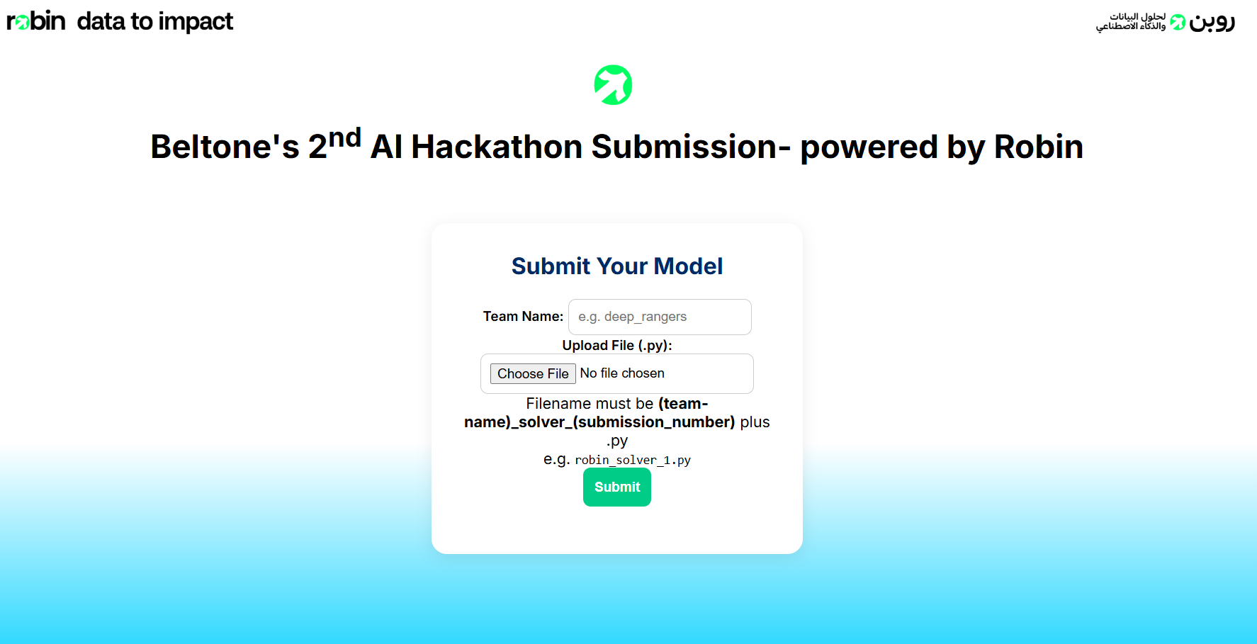
If you did another iteration (you can submit more than once to increase your ranking), then you should increment the number of submission id (eg: 1), to be 2 , then a 3rd iteration to be 3 , and so on…
example : 2nd iteration: Robin_solver_2.py
example : 3nd iteration: Robin_solver_3.py

